Module 1
This Module will help you understand how computers work and how to use them. You will learn about how to set up a computer, the difference between hardware and software, and the types of computers you can use. You will also explore operating systems, applications, the cloud, and much more.

Module Sections
  - What is a Computer?
  - Hardware Basics and Software Basics
  - Data Communications (The Internet, Networks, & IoT)

1.1 What is a computer?
According to Dictionary.com, a computer is “a programmable electronic device designed to accept data, perform prescribed mathematical and logical operations at high speed, and display the results of these operations.”
Watch the video to get an idea of what a computer really is. Think about this question: Are we (human beings) computers?
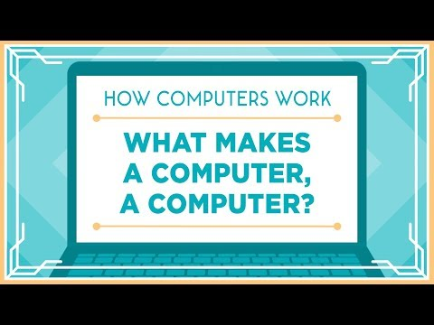
Direct video URL: https://www.youtube.com/watch?v=mCq8-xTH7jA
Video length: 5:09

A computer has four basic functions, these are input, process, output, and storage. Referring back to the question above, human beings perform the four basic functions and therefore could possibly be categorized as a computer.
- We have input in the form of our five senses.
- Our brain has a memory component which stores important information and discards unnecessary items.
- Our brain processes thoughts and ideas based on what is received from the five senses.
- We send output via speech, body language, and facial expressions.
Honestly, why do we even need computers?

1.2 Hardware and Software Basics
There are two major components of a computer system. These are hardware and software. The hardware is the physical components both inside the computer and outside the computer that mechanically operate the computer. The software is not a physical item but is still very real and assists the hardware by providing instructions and commands to also assist in operations

Hardware Basics
Computer hardware consists of the physical components of a computer system. It includes components inside the computer and outside the computer. The box containing the internal components of a basic desktop computer has many names such as chassis, tower, case, or system unit. This is the main external component of the computer which houses all the internal components. Internal components inside the case include the central processing unit (CPU), the motherboard, and two different types of memory storage, the power supply, and various expansion slots. Hardware components that are not necessarily required for the computer CPU to operate are usually called peripherals which can include secondary storage and input and output devices.

Hardware External Components
Secondary storage can technically be an external or an internal hardware component of a computer. There are a few different types of external secondary storage such as external hard drives and flash drives. This type of storage is usually portable and allows a person to carry data with them to use in other computers as needed.
The list of input and output hardware components seems unending. An input device is used to provide data or instruction to a computer. If a device is used to make the computer perform an action then it is considered an input device. A keyboard and a mouse or touchpad were probably the most common forms of input until touchscreens became popular. Keyboards, mice, and touchpads are still used of course, but only with stationary systems. Most mobile devices such as phones and tablets are now touchscreen. What are some other devices that are a computer input component?
Output devices provide the results of the action that your input devices request. The most common output devices are the monitor or screen and printers. For example, you could use the keyboard to type or input the math problem 5+6 into an on-screen calculator and the result of 11 displayed on the screen is the output. You can also go further and send a command to the printer to print the result for an additional form of output. What are some other devices that are computer output devices?

Hardware Internal Components
The motherboard is the main internal hardware component which connects all the other components together. The CPU resides on the motherboard and all circuits on the motherboard can be traced in some path back to the CPU. The CPU is the brain of the computer and all commands are processed here which are directly obtained from information residing in storage. The computer has internal storage in two categories, primary and secondary. Recall the mention that secondary storage could be considered both internal and external. Internal secondary storage is the computer’s internal hard drive and can also be a CD or DVD drive built in to the computer case. The primary storage is the random-access memory (RAM) and is commonly just called the computer’s memory. The RAM is the primary storage because it stores the information that is directly accessible by the CPU. The CPU fetches commands from the RAM and processes them in a sequential order. Oftentimes these commands require action from other internal components further down the line. Many of these components are in the form of cards which are contained in expansion slots on the motherboard. These can include video cards, sound cards, network cards, and so on. For example, many people who use their computers for online-gaming require increased video graphics and audio capabilities to make their gaming experience the best possible. Their computers will have higher capability video and sound cards inserted into the motherboard expansion slots to facilitate this optimal experience. Of course, none of these internal components can operate without a power source which is known as the power supply. Maybe the power supply is the most important internal component of all?

Software Basics
For hardware components to interact and perform, they require some sort of software. Software is an intangible component meant to activate and control the hardware and process input and output commands. There are two main types of software; system software and application software. Application software makes life easier for the end-user of a computer by allowing them to perform specific tasks such as sending an email or typing a letter. Examples of application software include word processing and graphics design software. System software supports internal computer function, manages hardware resources and provides a platform for application software to run upon. Some examples of system software include operating systems, device drivers, and system utilities. The operating system is of great importance and controls how signals move inside the box. In the next section we will cover how data moves between separate boxes or computers: data communications.
Watch the video below to get an overview of hardware and software.
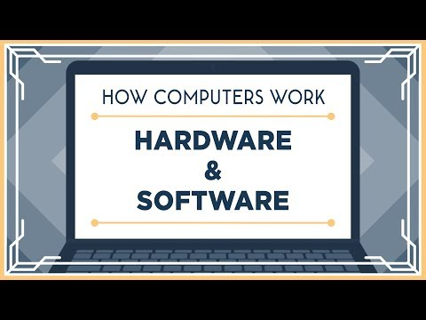
Direct video URL: https://www.youtube.com/watch?v=xnyFYiK2rSY
Video length: 5:22

1.3 Data Communications
According to Dictionary.com, data communications is the electronic transmission of information that has been encoded for storage and processing by computers. The systems that carry the electronic transmission of information are called networks. The largest and most well-known network is the Internet.
Watch the videos below for a better understanding of the Internet and the data communications of today.
What is the Internet?
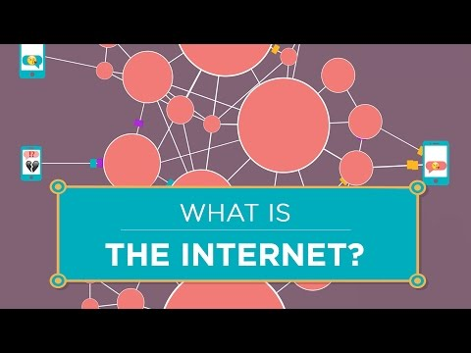
Direct video URL: https://www.youtube.com/watch?v=Dxcc6ycZ73M
Video length: 3:44
The Internet; Wires, Cables, and WiFi
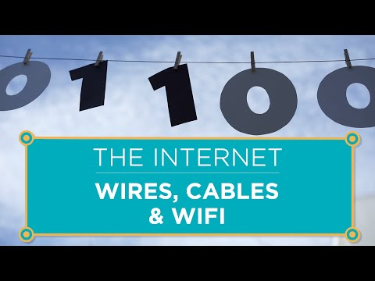
Direct video URL: https://www.youtube.com/watch?v=ZhEf7e4kopM
Video length: 6:41

Cloud Computing Explained
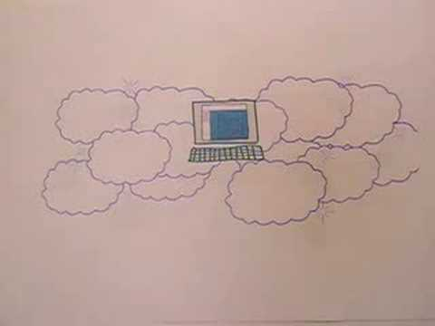
Direct video URL: https://www.youtube.com/watch?v=QJncFirhjPg
Video length: 1:06

Internet of Things Explained

Direct video URL: https://www.youtube.com/watch?v=5d1bZ2MBdvI
Video length: 2:26

Internet of Things – TEDx Talk
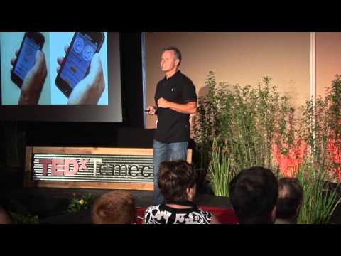
Direct Video URL: https://www.youtube.com/watch?v=_AlcRoqS65E
Video length: 16:37

Computer Basics
Complete the tutorials found at the link below to better understand computer basics.
https://edu.gcfglobal.org/en/computerbasics/
These tutorials are provided by Goodwill Community Foundations and cover the following topics.
- Getting to Know Computers
- Understanding Operating Systems
- Understanding Applications
- Web Apps and the Cloud
- Basic Parts of a Desktop Computer
- Buttons, Sockets and Slots on a Desktop Computer
- Inside a Desktop Computer
- Laptop Computers and Netbooks
- Getting to Know Mobile Devices
- Setting Up a Computer
- Beginning to Use Your Computer
- Getting to Know the OS
- Connecting to the Internet
- Computer Safety and Maintenance
- Basic Troubleshooting Techniques
Work through the Computer Basics Lessons, Interactives, and take the quiz under Extras. The quiz is not graded, but will provide you a good feedback on your understanding of the content.

Computer Components
Complete the tutorials found at the link below to better understand the components of computers.
https://www.javatpoint.com/computer-components
These tutorials are provided by JavaTpoint and cover the following.
- Computer Components
- Input Devices
- Output Devices
- Central Processing Unit
- Hardware
- Software

Internet of Things (IoT)
Complete the tutorials found at the link below to better understand the concepts of IoT.
https://www.javatpoint.com/iot-tutorial
These tutorials are provided by JavaTpoint and cover the following.
- IoT Introduction
- IoT Features
- Advantage & Disadvantage
- Embedded Devices and System
- IoT Ecosystem
- IoT Decision Framework

Module 1 Project
The goal of this project is to bring many of the strands together, in a grounded, real-world situation/scenario and which fully explores the potential and nature of connectedness.
The focus will be on ‘ecosystems’ of interacting internet devices. You are going to consider how several different devices can work together to solve a shared problem or create a life convenience.
What does an ‘ecosystem’ of IoT devices mean? Let’s use the analogy of cooking. To make a meal, we don’t just use one ‘thing’; we use a series of ‘things’ together. To cook our dinner, we need our fridge to store and keep the food fresh, a knife to chop, and cutting board to prepare on, a tin opener, a sauce pan, an oven, etc. All of these things work together to help us achieve the overall goal. Each of them as a specific function within the overall task. The same is true of the Internet of Things; real-world problems are complex, and often require a series of complementary devices or interacting systems that work with one another to achieve the desired outcome.
- Do some research and then some brainstorming and develop a future IoT concept for a major industry of your choice. You are to imagine a scenario that could feasibly exist in 5 years’ time. This should include a vision for an ecosystem of interacting connected products. This ecosystem would solve a problem, enhance the experience of your selected industry (or any aspect of it), or just make day-to-day life activity easier.
- You will need to develop (in theory) two to three device ideas that illustrate this concept and that interact with one another to support your problem or experience from item one. You must explain what they do and how they work together with each other.
- Post your ideas in well-formed sentences and paragraphs in the appropriate discussion forum.
- You must also provide respectful feedback to at least two (2) other students’ posts. This includes identifying what you may see as errors or maybe a better way to write their concept. Compliments are also always welcome however, all comments are to be at least two complete sentences and contain more than phrases such as “I agree.”

